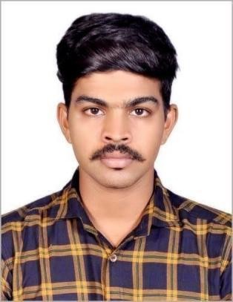

# PRASANTH. C S

✆: 9746980343 / 6369326374

@: [prasanthcs799@gmail.com](mailto:prasanthcs799@gmail.com)



* Working as Electrician around 3.5 years of experience in industry.
* Good experience for the electrical section of the Maintenance Department
* Responsible in transactions for importing machines and equipment’s

**PROFESSIONAL EXPERIENCE**

* Currently working Electrical Technician in Mall of Travancore Present in December 2021
* Worked as Senior Technician Engineer Department in Sarovar hotel in Trivandrum December 2019 to January 2021.
* Worked as Electrical General Technician in Hycinth By Sparsa Hotel, Trivandrum from July 2017 to August 2019
* Worked as Training in Maintenance Department in Hycinth By Sparsa Hotel, Trivandrum from January 2017 to June 2017.



# EDUCATION BACKGROUND

**Academic**: **S S L C**

Year-March 2012

University/Board: Board of publication Kerala

# Academic: PLUS TWO

Year-March 2014

University/Board: State Board of Tamil Nadu.

# Technical: Diploma in Electrical and Electronic Engineering

Year- 2014 to 2016 University/ Board: AICTE



Father’s Name : Chandrasekharan Nair

Date of birth : 18 Oct 1996

Sex : Male

Marital status : Single

Nationality : Indian

Religion : Hindu

Language Known : English and Malayalam Permanent Address : 2.132, Thamaravilagam Veedu,

Piracode,

Fathima Nagar (Post), Kanyakumari – 629160.

# DECLARATION:

I hereby declared that above mentioned Information furnished by me is true to the best of my knowledge and belief.

Place: Fathima Nagar With regards,

Date: